Joint-By-Joint Approach for Chiropractors:

If we manipulate an area that is inherently supposed to be stable it creates neurological confusion. The brain responds by tightening all the tissue around that area to provide artificial stability. Doesn’t sound right to you? How many patients come in and say, “I feel great after I get adjusted but the tightness returns a day or so later”? When patients tell me this I immediately think the body is searching for stabilization and does so by recruiting mover muscles to tighten. I get around this by uncovering the area that needs stabilization training. Addressing these areas that require stabilization training allows the superficial muscles to relax.

How do we know if an area of the body is supposed to be mobile or stable? Luckily physical therapist Gray Cook and strength coach Mike Boyle came out with a joint-by- joint approach to the body. They list areas of the body that mostly need to be mobile and areas of the body that mostly need to be stable. I also added a few more areas that are chiropractic specific (big toe, foot, lower/upper cervical). First lets start with areas that need to primarily be mobile. See Figure 1 for a graphical description.

Joint Primary Need
Big Toe – Mobility
Ankle - Mobility (sagittal)
Hip - Mobility (multi-planar)
Thoracic Spine - Mobility
Gleno-humeral – Mobility (multi-planar)
Upper Cervical – Mobility

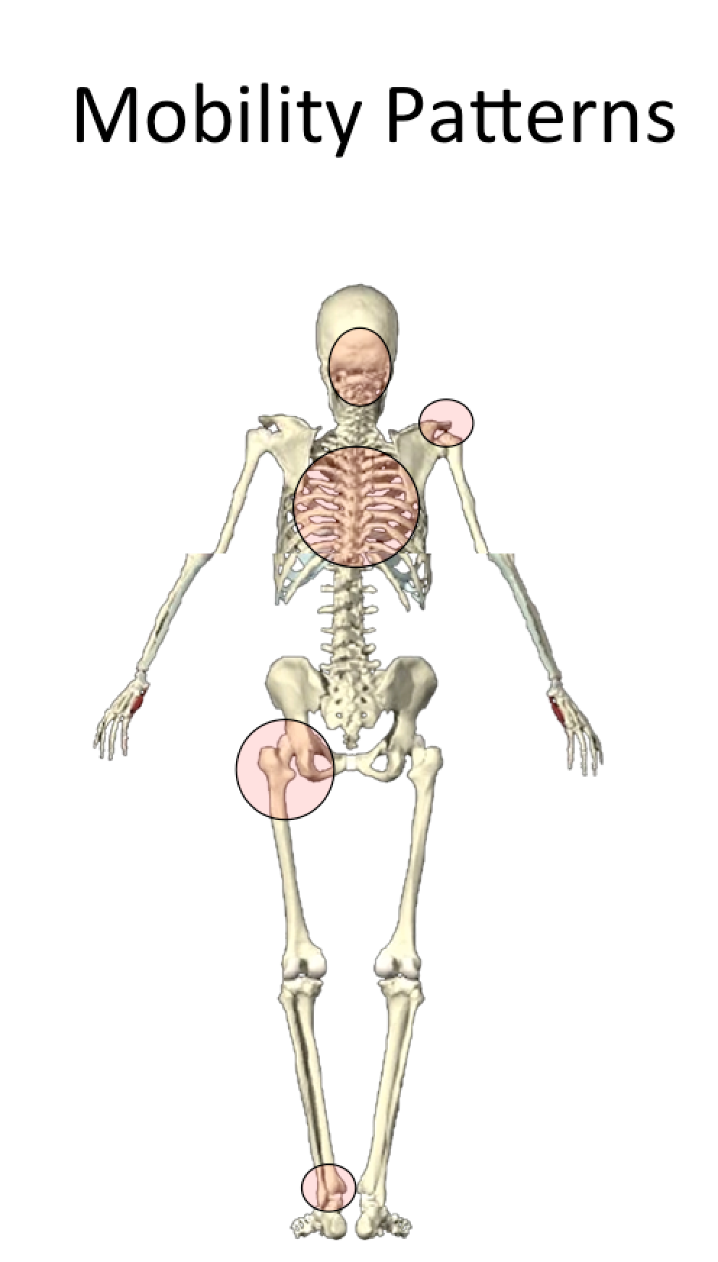
Figure 1. Joint of the body that inherently need to be mobile

Stability can also be termed motor control because really what we need is better communication between the brain and the stabilizing system of the joint not necessarily increased hypertrophy of the muscles. Motor Control is defined by Heritage Dictionary as, “The systematic transmission of nerve impulses from the motor cortex to the motor units, resulting in coordinated contractions of muscles”. Figure 2 shows areas that primarily need be stable via motor control. The stabilizing system of joints is composed of active (muscle) and passive (joint) and neurologic (brain and nerves). We can’t just call the joints stable because the definition of stability is, “The ability of an object to maintain equilibrium or resume its original, upright position after displacement from an outside force.” It is this unique ability of these joints to be stable while also being really mobile thus requiring the coordinated contraction of muscles to accomplish this difficult task.

Joint Primary Need
Foot/Arch - Stability
Knee - Stability
Lumbar Spine - Stability
Scapula - Stability
Lower Cervical - Stability

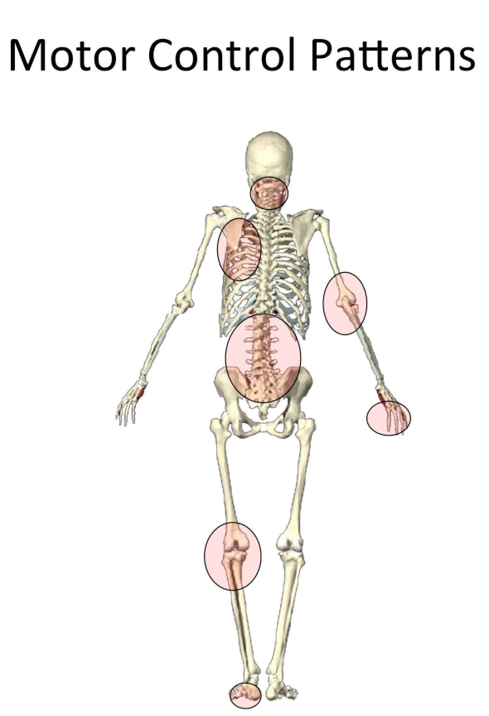
Figure 2. Areas that primarily need motor control or stability

The first thing you should notice is the joints alternate between mobility and stability. The ankle needs increased mobility, and the knee needs increased stability, etc. Personally, I think we are designed this way to have a more efficient transmission of forces throughout the body so not just one area accumulates the force and becomes injured.

Over the past 5 years of teaching all over the world, I am seeing a trend toward looking less at assessing joints or muscles in isolation to a more intelligent approach of assessing movement patterns. For example, instead of isolating glute medius when training the hip, we train the pattern of resisting internal rotation of the femur. There are more muscle than just glute medius in the hip and they all play a roll of either mover or stabilizer! Not to mention all the other muscles in the body that require a coordinated effort. Nothing works in isolation.

Using a whole body movement screen or assessment and identifying dysfunction, we can then look at individual regions to treat accordingly. Using the joint-by-joint approach gives us a good start at understanding if the area needs more mobility or more stability. Most good doctors, therapists and trainers have given up on the old isolated treatment methods and gone to a more regional approach to treat the area of complaint and then reintegrate that area with the rest of the body by grooving movement patterns. Some like to term this type of approach as treating movements-not-muscles.

In my opinion, injuries relate closely to joint dysfunction. The dysfunction may or may not be the area the patient is complaining of. The back may be symptomatic but the problem could be a lack hip mobility. Loss of function in the joint below–in the case of the lumbar spine, it’s the hips–seems to affect the joint or joints above. In other words, if the hips can’t move, the lumbar spine will move in excess to compensate. The problem is the hips are designed for mobility, and the lumbar spine for stability. When the intended mobile joint becomes immobile, the stable joint is forced to move as compensation, becoming less stable and subsequently painful. I like to take this a step further and say that the body is locking down the area and creating tightness because of instability somewhere else. The hips become tight because the core is not strong enough and the hip musculature is being recruited for artificial stability. This concept is akin to a golf cart. I can walk into a golf cart shop and buy a golf cart that can get up to speeds of 50mph and legally drive it on the road. When a golf course purchases these golf carts the first thing they do is put a governor on them to slow them down. Why? The risk of injury to the person driving the golf cart is higher with higher speeds. Our brain works the same way with our body….if injury risk is increased because speeds are too high the body will put the brakes on. In this example make the hips, which are supposed to be mobile, tight to slow the system down.
The Process is Simple:

Lose ankle mobility, get knee pain
Lose hip mobility, get low back pain
Lose thoracic mobility, get neck and shoulder pain, or low back pain

I teach my patients these joints have a specific mobility or stability need, and when they’re not using them much or are using them improperly, that immobility is more than likely going to cause a problem elsewhere in the body.

These are the results of joint dysfunction: Poor ankle mobility equals knee pain; poor hip mobility equals low back pain; poor T-spine mobility, cervical pain.

This fuels a vicious cycle. As the spine moves to compensate for the lack of strength and mobility of the hip, the hip loses more mobility. Lack of strength at the hip leads to immobility, and immobility in turn leads to compensatory motion at the spine. The end result is a kind of conundrum, a joint that needs both strength and mobility in multiple planes.

The lumbar spine is interesting. This is clearly a series of joints in need of stability, as evidenced by all the research in the area of core stability. The biggest mistake we have made in training over the last 10 years is an active attempt to increase the static and active range of motion of an area that requires stability.

Most, if not all, of the many rotary exercises done for the lumbar spine were misdirected. Physical therapist Shirley Sahrmann in Diagnosis and Treatment of Movement Impairment Syndromes and James Porterfield and Carl DeRosa in Mechanical Low Back Pain: Perspectives in Functional Anatomy all indicate attempting to increase lumbar spine range of motion is not recommended and is potentially dangerous. Our lack of understanding of thoracic mobility caused us to try to gain lumbar rotary range of motion, and this was a huge mistake.

If increased mobility is a mistake at areas like the lumbar spine, how do they respond when we manipulate and artificially put more mobility into the segments? In the short term we get increased motor control but that may only last for between 30 minutes and 24 hours. That’s why we get improved range of motion that slowly diminishes over a day or so. The way to keep this physiological window open is with some sort of neurosensory input to the area. I would recommend using kinesiology tape in conjunction with low force exercises to allow the brain to adapt to the new range of motion.

In my next article, I will discuss certain areas of the body and how to mobilize and stabilize using this joint by joint approach. If there are certain areas you would like to see, please contact me.

About the author:
Edward Le Cara, DC, PhD, ATC, CSCS recently sold his practice of 14 years in Northern California and relocated to Dallas, TX. He is the director of athletic training at The KinetikChain in Dallas and the Director of Trans Global education at RockTape. www.rocktape.com You can contact Ed by email (ed@rocktape.com) or Twitter/Instagram: @drlecara.

