Kinesio Tape – what is it, what does it do and what’s the evidence? – by Paul Coker
1 Reply
When we reviewed kinesiology tape last autumn we gave Rocktape a bit of a hard time. So we thought it was only fair to give them a chance to share their views on the topic. Medical Director of RocktapeUK and Physiotherapist Paul Coker has kindly agreed to give us the lowdown on all things kinesiology tape. You can follow Paul on Twitter via @Rockdocuk

Few people can have failed to notice the rise and rise of this often brightly coloured tape in recent years. Whether adorning Gareth Bales legs, Novak Djokovic’s back or covering half of TeamGB at London 2012, kinesiology tape (hence forth I’ll go with just tape) has been rapidly gaining popularity with athletes, patients and therapists alike.
While some people remain sceptical, and doubtful that is nothing more than a passing fad, convinced that all its reported positive effects are down to a heady cocktail of placebo effect and vanity.
Others, myself included, haveseen and felt its unique effects to reduce pain and enhance performance. Every day in clinic I see patients delighted and amazed when I tape them. Every time I teach a taping course I see sceptics become converts by wearing and feeling the tape work on them.
For many people, at the point they realise their pain/problem feels better when wearing tape, they stop asking questions. I am not that sort of people, this is for all those sceptical scientific, pragmatic, rational people..like me. I’m not going make the usual outlandish claims about what tape can do, and more importantly that we fully understand it.
“Does this tape make my calfs looks fat?” Ultra running legend and tape advocate Terry Conway at the office

WHAT IS KINESIOLOGY TAPE?

If I’m really honest there is much we don’t know about what tape can and can’t help, how it does what it does, what system within your body it is affecting. You know; the details. Let’s start with what we do actually know.

- The tape is made of tightly woven elasticated cotton (97%) and nylon (3%) fibres. Quality of these raw materials is critical to how well the tape wears and how well it resists plastic deformation. Cheap, naff tape gives itself away by having far fewer fibres per cm2, indicating a thick,and cheap cotton fibre. Nice tape (like Rocktape) uses really, really fine organic cotton fibres. These costs a little more but the end product is well worth it.
- The glue on the tape is acrylic, highly durable and waterproof so tape can be worn for up to a week withstanding vigorous movement, sweat and total emersion in water. Cheap tapes come of easily, resist water poorly and irritate the skin. Good tape (like Rocktape, Ok I’ll stopnow) has better quality glue which is more durable, kinder the on skin and more resistant to water, sweat etc.
- When applied in a vaguely correct manner tape canlead various positive changes including less pain, improved function, more power, better muscular endurance. (See what is the proof for details)

WHAT ITS NOT
- The tape does not contain any medication or drugs
- Different colours are cosmetic only, all colours of tape have the same elasticity and therefore benefits.
- Tape is not a replacement for sensible injury management and thorough rehab

WHAT WILL IT DO FOR ME?
Kinesiology tape is commonly used clinically to try and achieve the following:
- Reduce pain
- Drain swelling
- Improve posture
- Improve function
- Facilitate early return to activity or sport
- Improve sporting performance.

WHAT IS THE PROOF?

The popularity of KT has grown and spread worldwide based on its clinical effectiveness to reduce pain and enhance performance rather hard tangible evidence about how the effects are achieved.
Although still in its infancy, there are very encouraging signs from research studies and a body of independent academic research is growing to support the positive effects of tape.
There are conflicting messages coming from the research at present. Some studies show no effect of tape on the parameters they tested. Whilst others show that tape does change various things such as pain, strength, endurance etc. So it’s quite possible to cherry pick to form an argument either way.
All research is not equal, and many of the studies examining tape effects are at best on the small side and a worst poorly designed, badly written up and generally quite pants.
That said Research studies have shown kinesiology tape to:
- Improve power and strength in uninjured muscles (4,6,9)
- Reduce pain and improve function in painful conditions like plantar fasciitis and Patello-femoral pain. (1,2)
- Improve pain, range of motion and function in people with shoulder impingement (5,7,8)
- Raise the anaerobic threshold of muscle during endurance activity (3)
- A recent systematic review (a research studies into a bunch of other papers on a similar topic) concluded that there was ‘moderate evidence to support the use of tape to reduce pain’ (6)

HOW DOES IT WORK?
Cards on the table: Nobody is 100% sure how it works. An amazingly little amount of research has gone into the fundamental mechanics of how tape works.
This is my best guess until more research comes along.Fundamentally tape causes a form of decompression between the skin and the tissue underneath. When an elastic membrane (tape) is applied to another elastic material (skin) the result is often a series of wrinkles in both the tape and the skin.
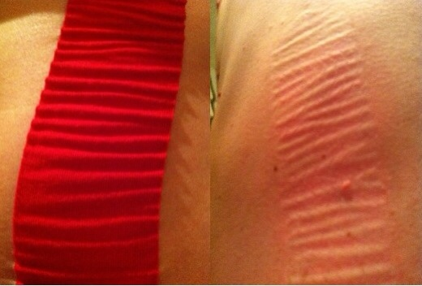
Left: tape on skin showing wrinkles Right: skin immediately after tape has been removed

These wringles don’t always appear and arent necessary for tape to work. But they do make a good visual example of the mechanism by which the elastic qualities if kinesiology tape induces a decompressive effect bteween skin and the tissue under it.

This decompression of the skin and underlying tissue leads to 3 main effects:

FLUID EFFECT
- The elastic properties of tape induce a vertical lift of skin (via the formation of wrinkles) from the underlying tissue.
- This decompresses the space between skin and muscle. This space (subcutaneous space) contains lots of important stuff like nerve ending, blood vessels etc
- This decompression promotes improved blood and lymphatic flow into and out of the taped area.
- This allows the more rapid removal of injury waste products and pain generating chemicals, and promotes healing.
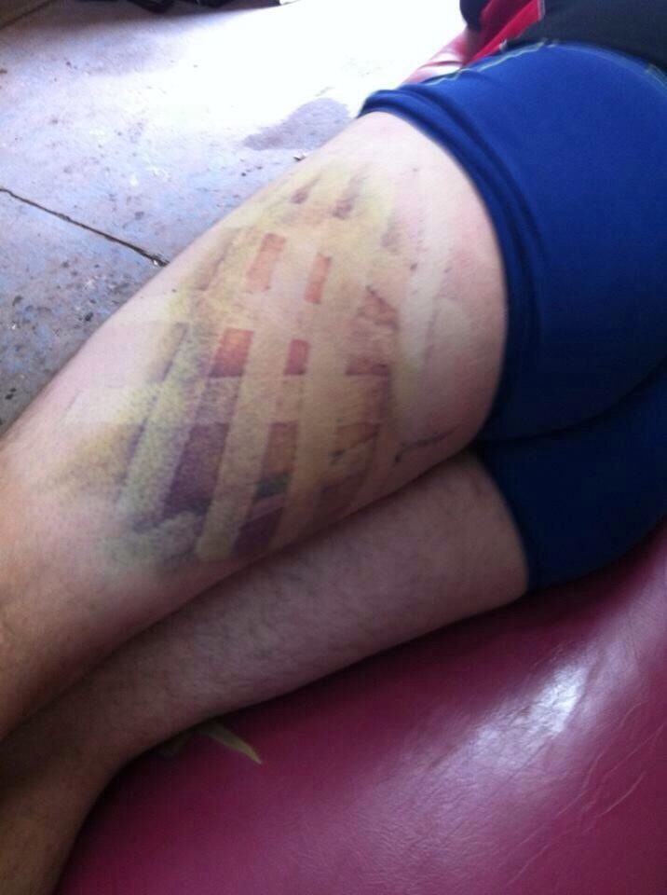
Aiding the clearance of a large bruise or heamatoma is a good example of a time when the fluid effect is working

MECHANICAL EFFECT

- Tape has longitudinal stretch properties of about 140-180%.
- These stretch properties are similar to those of skin, muscle and connective tissue.
- This helps the body’s stabilisation system by adding a little extra stability, spring and awareness of stretch to muscles, ligaments, tendons joints etc
- It may also have a role in restoring normal slide and glide mechanics between layers of tissue

NEUROLOGICAL EFFECT
- The presence of tape on the skin helps to create a non-painful stimulus from the area this makes it more difficult for the nervous to feel pain in that area (Pain gate)
- The decompressive properties of the tape (think wrinkles) reduce pressure and compression on nerve endings just under the skin making them fire less.
- Tape placed over really tight muscles seems to reduce the response to being stretched, making them feel less tight and sore.
- Tape placed over weak, sore and injured tissue will act to aid the bodies ‘active’ stabilisation by altering the activity and feedback from nerves in the skin and underlying tissue.
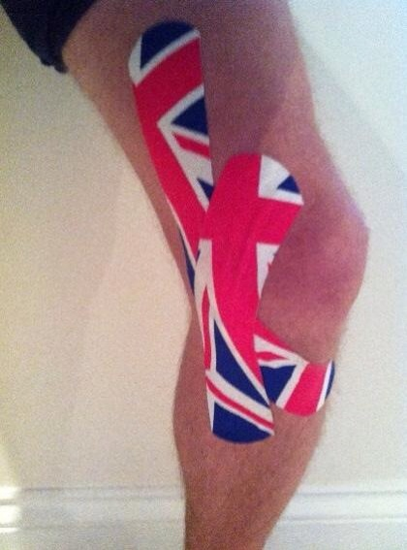

WHO CAN USE IT?
- Kinesiology tape can be worn by almost anyone from children to the elderly.
- It can be used to help almost any pain or dysfunction being caused by the bodies’ musculo-skeletal system.
- Simple applications are fairly straightforward and easy enough to make a success of with self-application. (Providing you can reach; some areas necessitate a second pair of hands).
- Although the glue is tough and durable. The tape can be removed with very little discomfort and leaves leaving no residue on the skin.
- Because the glue is acrylic it contains no latex so can be used by those allergic to most other tapes.

ANY DRAWBACKS?
- Very occasionally it can cause an allergic skin reaction
- If too much tension is placed on the ends of the tape it can irritate and inflame the skin
- Its not a miracle cure. It won’t mend broken bones or instantly fix serious injury.
- It doesn’t work like a plaster on a wound. To get maximum effect the right combination of tape and tissue stretch is vital.

I’M SOLD;WHAT NEXT?
- Firstly if you are in any doubt about what causes your pain seek the advised of a well qualified experienced health professional
- Kinesiology tape is often used by physiotherapists, osteopaths, chiropractors and sports therapists and similar health professionals. It is a good idea to get them to show you how to apply the best tape for particular pain/injury.
- Most significant problems need some other treatment alongside taping your friendly health professional can advise you about this

CAN I TRY TAPING MYSELF?
You can. I will (if Tom will have me) be back with a follow up article on the simplest most effective ways to tape for common running injuries. In the meantime here are a few pointers to get you started.
If you have:
- Mild to moderate pain on movement or exercise.
- No major swelling or bruising
- No major loss movement or strength

‘X MARKS THE SPOT’ APPLICATION
This is pretty much the simplest way to start taping up a sore bit, depending on where you intend to tape up you might need to enlist a volunteer to lend a hand
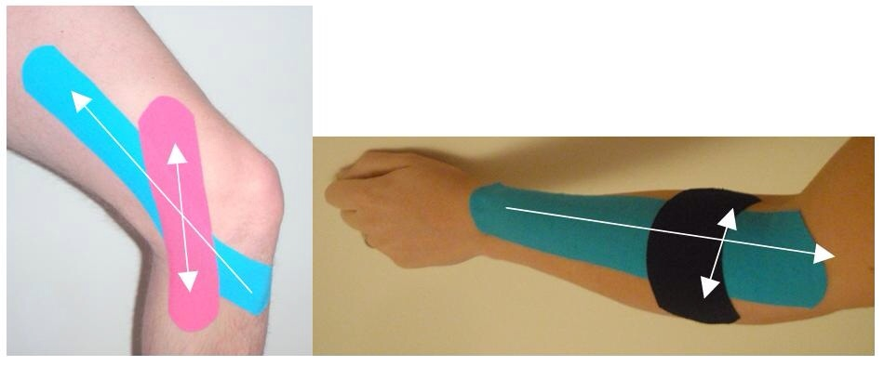

- Stretch the muscle/tissue in the area you want to tape as much as pain allows
- Cut a longish piece of tape (min 3xlonger than your sore bit) Tear the backing paper close to one end and stick the end down with no stretch on the tape. Peel the backing paper away as you stick the tape in line with the tissue with just the amount of stretch that is already on the tape. (Blue strip)
- Take a second short piece of tape, tear the paper in the middle and peel it back so ½ the tape is exposed, stretch it a little and lay it like a plaster right over the sore bit roughly perpendicular to the first bit. (Pink/Black strip)
- Always lay the first and last 3-5cm of tape with no stretch at all.
- Rub the tape all over before you start moving about to activate the glue.
- Hopefully you’ll start feeling better right away; if you do keep the tape on for 3-5 days
- If your problem doesn’t feel that much difference give it 24hrs

REFERENCES
- Chen,W., Hong, W., Huang, T.F., & Hsu, H., (2007) Effects of kinesio taping on the timing and ratio of vastus medialis obliquus and vastus lateralis for person with patellofemoral pain. Journal of Biomechanics. 40(S2), S318
- Chien-Tsung Tsai et al. (2010) Effects of Short-term Treatment with Kinesiotaping for Plantar Fasciitis. Journal of Musculoskeletal Pain, 18 (1) 71-80
- Dae-Young K, Byoung-Do S. (2012). Immediate Effect of Quadriceps Kinesio Taping on the Anaerobic Muscle Power and Anaerobic Threshold of Healthy College Students Journal of Physical Therapy Science; Vol. 24 Issue 9, p919
- Fratocchi, G et al. (2012). Influence of Kinesio Taping applied over biceps brachii on isokinetic elbow peak torque. A placebo controlled study in a population of young healthy subjects. Journal of Science and Medicine in Sport July 2012
- Hsu, Y., Chen, W., Lin, H., Wang, W.T.J., & Shih, Y., (2008). The effects of taping on scapular kinematics and muscle performance in baseball players with shoulder impingement syndrome. Journal of Electromyography and Kinesiology. 19, 1092-1099
- Kalron A, Bar-Sela S. (2013) A systematic review of the effectiveness of Kinesio Taping® – Fact or fashion? Eur J Phys Rehabil Med. 2013 Apr 5
- Thelan, Dauber & Stoneman (2008). The Clinical Efficacy of Kinesio Tape for Shoulder Pain: A Randomised, Double-Blinded Clinical Trial. Journal of Orthopaedic and Sports Physical Therapy, 38 (7) 389-395.
- Simsek et al. (2013). Does Kinesio taping in addition to exercise therapy improve the outcomes in subacromial impingement syndrome? A randomized, double-blind, controlled clinical trial. Acta Orthop Traumatol Turc;47(2):104-110
- Wong, O. M. H., et al., Isokinetic knee function in healthy subjects with and without Kinesio taping, Physical Therapy in Sport(2012), doi:10.1016/j.ptsp.2012.01.004
- Yoshida, A.& Kahanov, L., (2007). The effect of kinesio taping on lower trunk range of motions. Research in Sports Medicine 15 103-112.

