ROCKTAPE - HAND APPLICATION

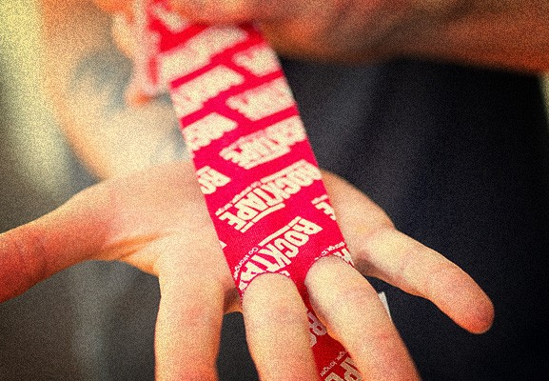

There is nothing worse than being in the middle of a WOD and feeling your hands starting to tear. Do you keep going and just deal with the pain after or do you stop? I don’t know about you but I’ve never stopped in the middle of a WOD so I’ve dealt with many a torn callus. They are very annoying and painful.
Rocktape have the answer to this problem. You can use their tape on your hands and it helps to stop them from tearing. This is especially useful in a WOD like Murph when you’ve got 100 pullups to get through.
When we spoke to Tony Stahl from Rocktape he ran us through how to apply the tape correctly to help with torn hands. The great thing is you can make up a bunch of these Hand Tapes and keep them in your bag so if you turn up at the gym and there’s pullups in the workout you can put them on before the class.
Here are the steps:
Step 1
Ensure your hands and lower forearms are dry and free of moisturisers and sunscreen.
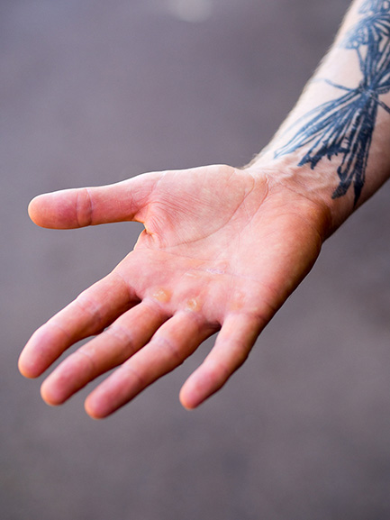
Step 2
Measure a piece from the tip of your middle finger to the middle of your forearm. In my case that is 30cm.
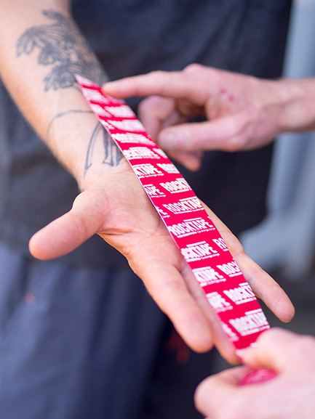
Step 3
Round the edges of the Rocktape, ie. like a band aid and that will stop the corners getting caught on things and lifting.
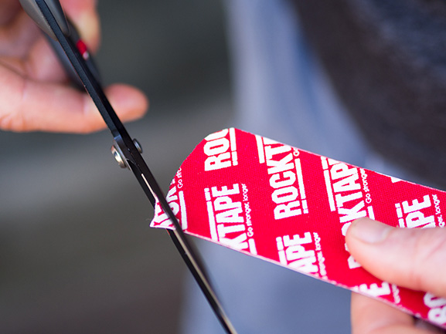
Step 4
Fold the Rocktape in the middle and then cut 2 small holes (half circles).
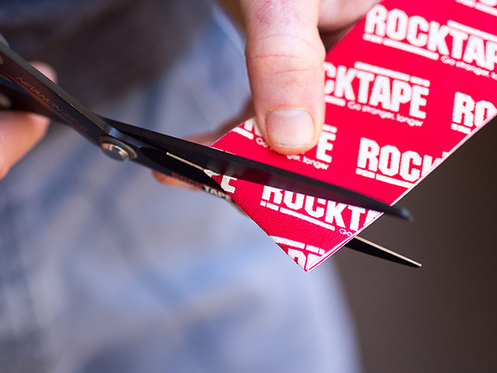
Step 5
Then open the Rocktape up and the holes should look like a pair of eyes/oval shape. It is important not to make the holes you cut too big or when you pull it over your fingers it won’t protect the area at the end of your fingers where the blood blisters or calluses form.
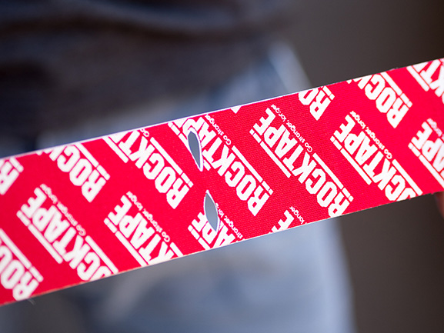
Step 6
Rip the Rocktape in the middle where the holes are by pulling from each end.
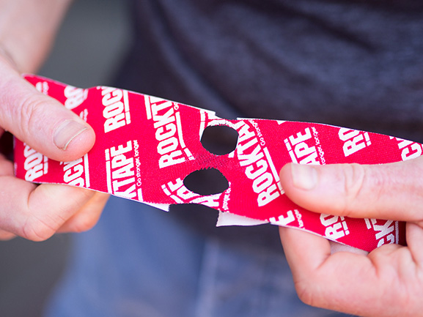
Step 7
Place the 2 middle fingers in the holes and pull the Rocktape down over the fingers. Ideally it should be a bit of a struggle to get it over the 2nd knuckle and that means you have made the holes a good size.
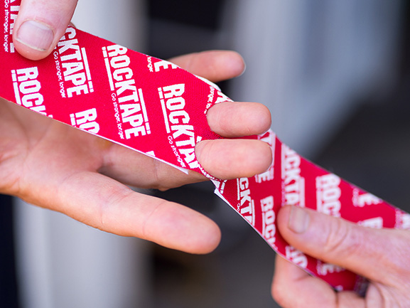
Step 8
Once the Rocktape is at the ends of your fingers peel off the backing piece of the Rocktape on your palm side and spread your hand and place the Rocktape down while applying just a small amount of stretch. Applying no stretch at the end, ie. last 2cm of the Rocktape.
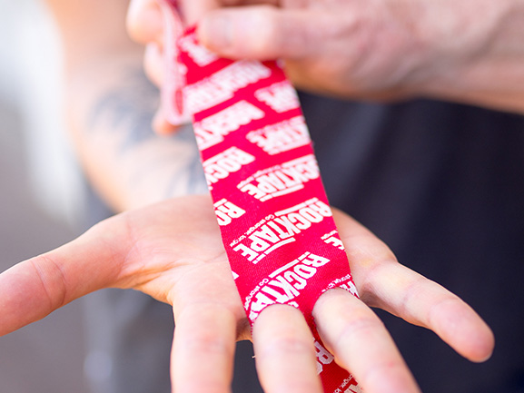

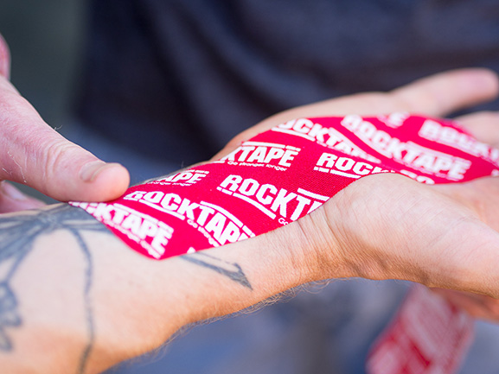
Step 9
Turn your hand over and apply the Rocktape over the back of your hand with a small amount of stretch. Applying no stretch at the end, ie. last 2cm of the Rocktape.
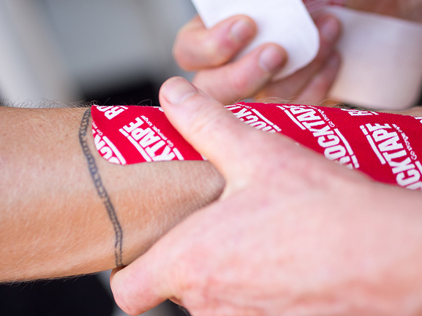
Step 10
The adhesive is heart activated so then rub the Rocktape to generate some heat to start the bonding process of the adhesive to the skin.
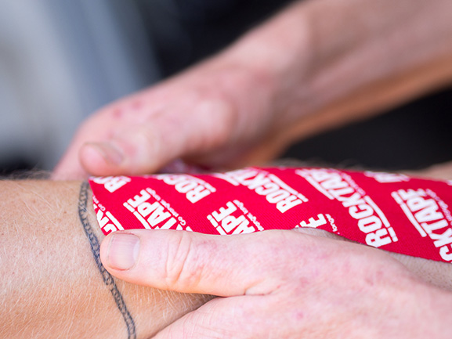
Ideally apply the Rocktape 10-15 minutes before you start sweating to allow plenty of time for the adhesive to bond to the skin.

