ROCKTAPE - MORE THAN JUST A FASHION ACCESSORY

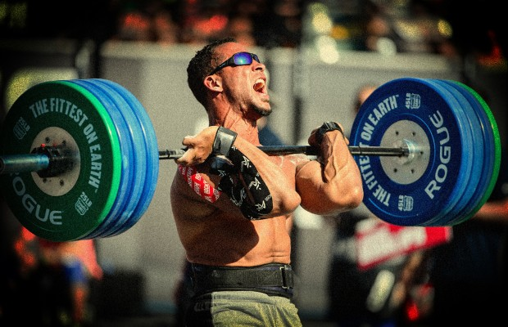

Rocktape has been working with CrossFit athletes since the 2010 world games. Rocktape is more than just a fashion accessory and is a valuable technique to assist with performance enhancement, athlete recovery and injury prevention. Unlike rigid tape which many people find too stiff and restrictive, Rocktape is stretchy and is quickly becoming the preferred tape used by CrossFit athletes.
How does it work? When applied correctly, Rocktape’s unique elasticity causes the skin to form convolutions and wrinkle. This decompresses the tissue immediately below the skin. It is believed that this has three main effects:
1. Fluid effect – improving blood and lymphatic flow in the taped area which may help reduce the build up of lactic acid when exercising and/or assist remove swelling or bruising.
2. Mechanical effect – improving the slide and glide between tissue layers which may assist increase mobility.
3. Neurological effect – altering the perception of pain (pain gate theory) and improving body awareness to assist us maintain a better technique.
Six common Rocktape applications for CrossFit athletes:
- Muscle pain or cramping – some WOD’s involve an activity which causes significant fatigue to a muscle or group of muscles. This might be due to the activity not being one we have done often previously or be as a result of the number of reps completed. For some of us it might be double unders (calf), or box jumps (Achilles), or dead lifts (lower back), or thrusters (quads). The discomfort can last for days and impact our ability to do other WODs on the same day in competitions, or subsequent days in training. Applying the Rocktape before the activity (prehab), may allow you to go stronger for longer, delaying the effects of fatigue while doing the applicable activity, and the Rocktape can also reduce the amount of muscle soreness felt in the hours and days after completing the activity. The application of the Rocktape after the activity (rehab), can also reduce the amount of muscle soreness experienced post the WOD.
- Joint pain – shoulder, knee or elbow pain is often felt during or after activities we complete in WOD’s. The pain could be as a result of poor technique causing us to over use certain muscles, or even flaring up a pre existing injury that hasn’t been completely resolved. The application of Rocktape before any activity that could aggravate the condition may assist alleviate the symptoms felt by providing some functional support and stability for the joint, and/or provide some positional stimulus to help correct the incorrect technique we are utilising. Particularly when under increased load or as we fatigue.
- Prevention of blisters on hands – many of us have experienced blisters on our hands which is often associated with pull ups and toes to bar activities. The application of Rocktape before any activity (prehab) which you find is particularly hard on your hands can significantly reduce the amount of discomfort felt during and after the WOD. The Rocktape effectively forms a layer for protection but importantly the elastic nature of the Rocktape still allows you to grip the bar effectively.
- Poor posture – as a result of spending a lot of time sitting in front of computers many of us have developed some rounding of our shoulders. Alternatively, when doing an activity such as dead lifting we may round our back when under increased load or as we fatigue. The application of Rocktape before the activity (prehab) may assist us be able to maintain a better posture and allow us to utilise the muscles we are supposed to be activating when completing the activity. Therefore both improving our performance and reducing the risk of injury. Rocktape can also be applied after the activity (rehab) and it has the ability to provide on going corrective feedback whenever we slump forward in front of the computer. A bit like a nagging wife or husband poking us in the back and telling us to sit up straight.
- Inflammation or bruising – after exercise we can often experience swelling or bruising. Rocktape can be applied after the activity (rehab) to assist reduce the congestion which can then alleviate any pain we are feeling. You can still ice over the top of the Rocktape. The elastic nature of the Rocktape can allow you to have some movement in the area which allows optimal loading which is also important in the recovery phase. The “jelly fish” application is often the most successful at reducing congestion and is also one of the most eye catching applications – so it can also be popular for this reason for those who like to be noticed
- Zinc oxide allergies – some people unfortunately experience an itchiness when wearing rigid tape due to the zinc oxide in the adhesive. Rocktape uses an acrylic adhesive that is much gentler on the skin and very rarely causes an irritation for the athlete.
Other key benefits of using Rocktape
- Water resistant – can be worn for up to 5 days
- Available in 30 different colours and patterns so we have something to suit every personality type.
- There are 30 on line video demonstrations on how to apply your Rocktape applications available at rocktape.com.au/videos
Rocktape is available to be purchased on line at rocktape.com.au or through numerous retail outlets including some CrossFit boxes, pharmacies or sports stores. A list of retailers is provided at rocktape.com.au/retail-stockists
Want to organise a Rocktape session at your box? In these sessions we demonstrate the commonly used CrossFit applications and provide an opportunity for you to do some taping to see how easy it is to apply Rocktape. Ask your box owner or coach to contact tony@rocktape.com.au

